**APPENDIX B.2**

**2023-24 SOUTH OC WQIP ANNUAL REPORT  
MS4 OUTFALL DISCHARGE ASSESSMENT**

Contents

1 Introduction 1-1

1.1 MS4 Outfall Monitoring and Assessment Background 1-1

1.2 MS4 Outfall Monitoring 1-1

1.2.1 MS4 Outfall Inventory 1-1

1.2.2 Field Screening and Expanded Outfall Observations 1-1

1.2.3 Non-stormwater Persistent Flow MS4 Outfall Discharge Sampling 1-1

1.2.4 Wet Weather MS4 Outfall Discharge Monitoring 1-2

1.3 MS4 Outfall Discharge Assessment 1-2

2 Results 2-1

2.1 MS4 Outfall Monitoring and Assessment 2-1

2.1.1 MS4 Outfall Discharge Monitoring Station Inventory 2-1

2.1.2 Dry Weather MS4 Outfall Discharge Monitoring 2-2

2.1.3 Non-Stormwater Discharge Assessments 2-10

2.1.4 Wet Weather MS4 Outfall Discharge Monitoring 2-13

2.1.5 Stormwater Action Levels (SALs) 2-16

2.1.6 Stormwater Pollutant Discharges Reduction Assessments 2-18

Tables

Table 2‑1. Summary of Major Outfall Inventory and Accessibility by Jurisdiction. 2-2

Table 2‑2. Field Screening and Expanded Outfall Observations Monitoring Summary by Jurisdiction. 2-2

Table 2‑3. Water Quality Discharge Sampling Summary by Jurisdiction. 2-5

Table 2‑4. Summary of NALs Exceedances. 2-9

Table 2‑5. Jurisdictional Non-Stormwater Volume Connected to Receiving Water per Monitoring Year (October 1 – September 30). 2-11

Table 2‑6. 2023-24 Non-Metals Non-Stormwater Pollutant Loads. 2-12

Table 2‑7. 2023-24 Total Metals Non-Stormwater Pollutant Loads (pounds). 2-12

Table 2‑8. 2023-24 Dissolved Metals Non-Stormwater Pollutant Loads (pounds). 2-13

Table 2‑9. Outfall Stormwater Volumes. 2-14

Table 2‑10. Bacterial Concentrations in Storm Samples. 2-15

**Table 2‑11. Pesticide Concentrations in Storm Samples.** 2-15

Table 2‑12. Polycyclic Aromatic Hydrocarbon Concentrations in Storm Samples (ng/L). 2-16

Figures

Figure 2-1. Major Outfalls in the South Orange County Watershed Management Area. 2-1

Figure 2‑2. Outfall Connectivity to Receiving Water. 2-3

Figure 2‑3. Outfall Flow Contribution to Receiving Waters. 2-4

Figure 2‑4. Outfall Trash Assessment. 2-5

Figure 2-5. Dry Weather Outfall Sampling Locations. 2-6

Figure 2‑6. Dry Weather Outfall Chemistry (NALs parameters). 2-8

Figure 2‑7. Potential Sources Contributing to NALs Exceedances. 2-10

Figure 2-8. Wet Weather Outfall Monitoring Locations. 2-14

Figure 2‑9. Wet Weather Outfall Chemistry (SALs Parameters). 2-17

Figure 2‑10. Annual Percentage of SAL Exceedances. 2-17

Figure 2‑11. Cadmium wet weather concentrations. 2-18

Figure 2‑12. Lead wet weather concentrations. 2-19

Figure 2‑13. Zinc wet weather concentrations. 2-19

Figure 2‑14. Nitrate + Nitrite as N wet weather concentrations. 2-20

Figure 2‑15. Total Phosphorus as P wet weather concentrations. 2-20

Attachments

Attachment 2-1: Outfall Inventory

Attachment 2-2: Outfall Screening Data, 2023-24 Reporting Year

Attachment 2-3: Dry Weather Data

Attachment 2-4: NALS Assessment

Attachment 2-5: Information from Permittees on Identifying Flow Sources

Attachment 2-6: Non-Stormwater Volumes (2023-24)

Attachment 2-7: Jurisdictional Non-Stormwater Volumes and Loads (2023-24)

Attachment 2-8: Wet Weather Stormwater Discharge Data

Attachment 2-9: SALs Assessment

Attachment 2-10: Wet Weather Loading at Monitored Outfalls

Attachment 2-11: Wet Weather Annual Jurisdictional Loads

Attachment 2-12: Wet Weather Annual Outfall Tributary Loading by Land-Use (Percentage)

# Introduction

## MS4 Outfall Monitoring and Assessment Background

MS4 outfall discharge monitoring has been performed since 2015 in compliance with the San Diego Regional MS4 Permit (Order R9-2013-0001 as amended by Order No. R9-2015-001 and Order No. R9-2015-0100) (Permit) and in support of strategies to address the highest priority water quality conditions (HPWQCs) within the South Orange County Watershed Management Area (South OC WMA) Water Quality Improvement Plan (WQIP).

An objective of MS4 outfall monitoring is to measure the effectiveness of Permittee strategies to eliminate prohibited non-stormwater discharges and reduce pollutants in stormwater and allowable non-stormwater discharges. MS4 outfall monitoring also supports assessment of the strategies to address Unnatural Water Balance and Pathogen Health Risk highest priority water quality condition (HPWQCs).

This report describes assessments performed during the 2023-24 monitoring year (October 1, 2023 – September 30, 2024).

## MS4 Outfall Monitoring

### MS4 Outfall Inventory

**Permit Provision** **D.2.a.(1)** requires development of an inventory of major outfalls that discharge directly to receiving waters. Major outfalls include outfalls that are 36” or greater in diameter or that have a drainage area greater than 50 acres. Since 2015, the outfall inventory and record of observations has been documented and published to an ESRI geodatabase[1].

### Field Screening and Expanded Outfall Observations

Field screening and expanded outfall observations are performed at 80% of the outfalls in the MS4 outfall inventory for each jurisdiction twice each year during dry weather. Objectives include identification of non-stormwater and illicit discharges (**Permit Provision E.2.c**), determine if discharges are transient or persistent flows, and help prioritize and eliminate persistent flows through targeted programmatic actions and source investigations (**Permit** **Provision E.2.d**).

### Non-stormwater Persistent Flow MS4 Outfall Discharge Sampling

Using flow data collected through field screening and expanded outfall observations, as well as historical data, outfalls are prioritized for more intense sampling efforts, including more detailed flow monitoring and collection of water quality samples. Objectives include assessing persistent non-stormwater discharges against non-stormwater action levels (NALs) (**Permit** **Provision C.1**), determining the relative condition of MS4 outfalls to priority water quality conditions during dry weather, and investigating the sources of non-stormwater flows.

### Wet Weather MS4 Outfall Discharge Monitoring

Prioritized outfalls are also monitored once per year during wet weather. Objectives include assessment of stormwater discharges against stormwater action levels (SALs), determination of the relative contribution of MS4 outfalls to priority water quality conditions during wet weather, and investigation of change over time in discharge concentrations, loads, and flows at representative MS4 outfalls.

## MS4 Outfall Discharge Assessment

Discharge assessment allows Permittees to assess the effectiveness of strategies designed to eliminate prohibited non-stormwater discharges into the MS4 and reduce pollutants in stormwater discharges from the MS4. Therefore, discharge assessment includes identification of sources of controllable flows and pollutants contributing to NAL and SAL exceedances, prioritization of outfalls according to receiving water threat, estimation of discharge volumes and pollutant loads, data analysis, and identification of data gaps.

# Results

## MS4 Outfall Monitoring and Assessment

### MS4 Outfall Discharge Monitoring Station Inventory

**Figure 2-1** shows major outfalls in the South OC WMA. The complete inventory is provided in **Attachment 2-1** and is also available through the OCPW Open Data Portal[2].



Figure 2-1. Major Outfalls in the South Orange County Watershed Management Area.

There are 351 verified major outfalls in the inventory, 325 of which have been identified as safely accessible. **Table 2‑1** summarizes field verified and accessible (field staff are able to approach the outfall for flow observations or measurements without encountering obstacles, such as overgrown vegetation, or deeply ponded water) major outfalls by jurisdiction.

|  |  |  |
| --- | --- | --- |
| **Jurisdiction** | **Verified Outfalls in Field Screening Inventory** | **Verified Accessible Outfalls** |
| Aliso Viejo | 22 | 21 |
| Dana Point | 31 | 31 |
| Laguna Beach | 33 | 31 |
| Laguna Hills | 3 | 1 |
| Laguna Niguel | 44 | 40 |
| Laguna Woods | 3 | 2 |
| Lake Forest | 18 | 17 |
| Mission Viejo | 38 | 37 |
| Rancho Santa Margarita | 22 | 18 |
| San Clemente | 42 | 41 |
| San Juan Capistrano | 44 | 39 |
| Orange County | 51 | 47 |
| Total | 351 | 325 |

Table 2‑1. Summary of Major Outfall Inventory and Accessibility by Jurisdiction.

### Dry Weather MS4 Outfall Discharge Monitoring

#### Field Screening and Expanded Outfall Observations

**Table 2‑2** shows field screening observations were recorded at least twice for the reporting year at 275 outfalls. **Attachment 2-2** is the complete dataset from all field screenings for the current reporting year. **Figure 2‑2** summarizes average connectivity evaluations (direct connection, no connectivity, partial connectivity, or undetermined) determined during the field screening site visits for all major outfalls and whether persistent flow was observed.

Table ‑. Field Screening and Expanded Outfall Observations Monitoring Summary by Jurisdiction.

| **Jurisdiction** | **Verified, accessible outfalls in field screening inventory, 2024** | **Field screening target (80% of accessible outfalls)** | **Major outfalls with 2 or more field visits** |
| --- | --- | --- | --- |
| Aliso Viejo | 21 | 17 | 17 |
| Dana Point | 31 | 25 | 26 |
| Laguna Beach | 31 | 25 | 26 |
| Laguna Hills | 1 | 2 | 3 |
| Laguna Niguel | 40 | 32 | 32 |
| Laguna Woods | 2 | 2 | 3 |
| Lake Forest | 17 | 14 | 14 |
| Mission Viejo | 37 | 30 | 30 |
| Rancho Santa Margarita | 18 | 15 | 15 |
| San Clemente | 41 | 33 | 34 |
| San Juan Capistrano | 39 | 32 | 36 |
| Orange County | 47 | 39 | 39 |
| **Total** | **325** | **266** | **275** |

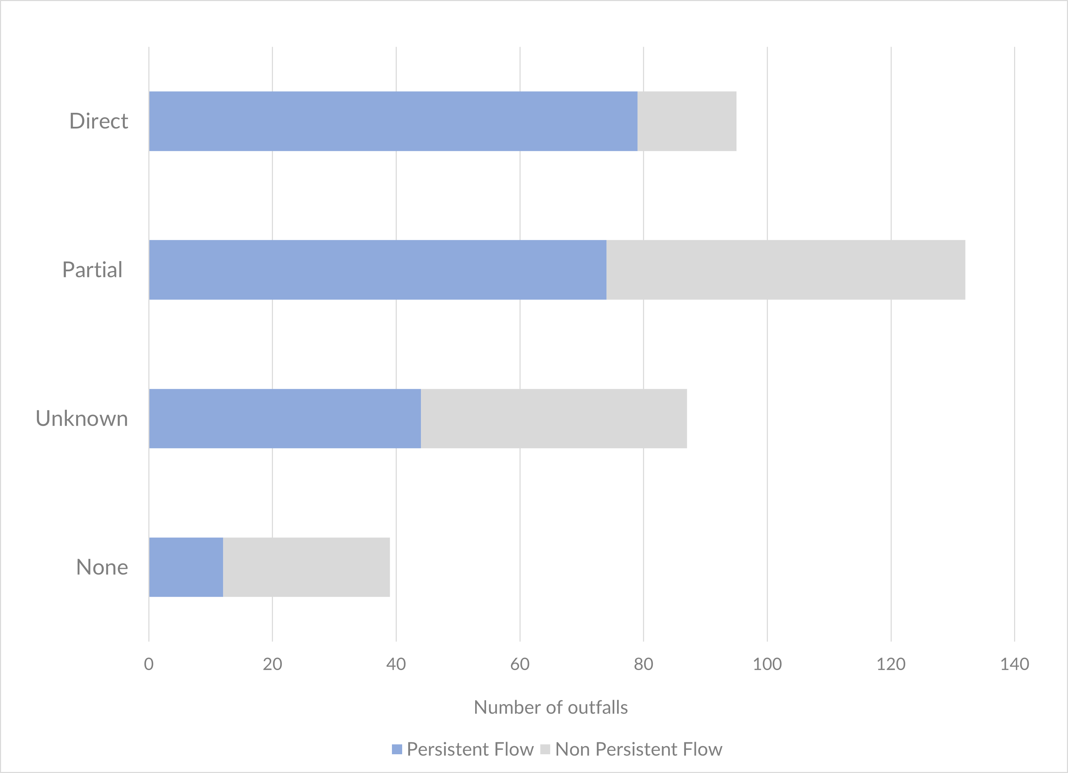

Figure 2‑2. Outfall Connectivity to Receiving Water.

Where it could be safely observed, field screening documented relative contribution of flow from an outfall to the receiving water. Field screen observations record whether a major outfall contributed a major fraction (>50%), minor fraction (10-50%), or small fraction (<10%) of flow to the receiving water. **Figure 2‑3** shows that for the 2023-24 reporting year, where connectivity to receiving water was observed, the vast majority of observations showed flow from outfalls contributed a small fraction of overall flow (<10%) to the receiving water. The trash condition in the vicinity of the outfall for all field screening observations is shown in **Figure 2‑4**. For 2023-24, 52% of field screening observations recorded sparse or no trash.

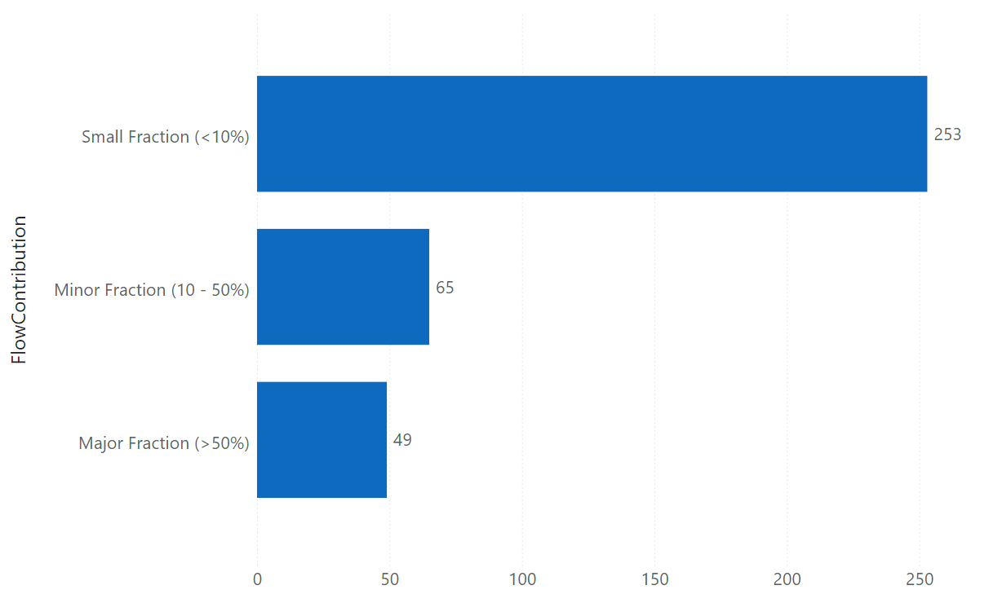

Figure 2‑3. Outfall Flow Contribution to Receiving Waters.

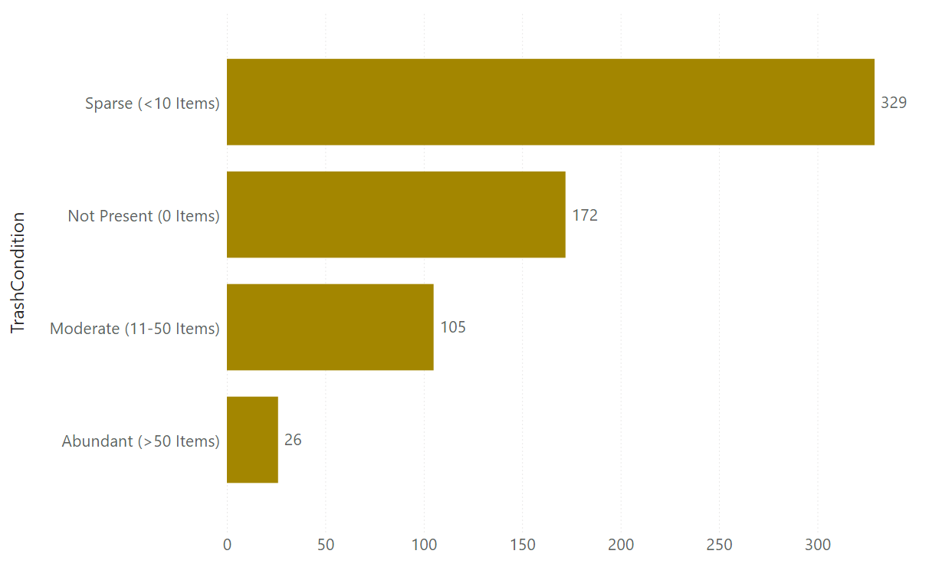

Figure 2‑4. Outfall Trash Assessment.

#### Non-stormwater Persistent Flow MS4 Outfall Discharge Sampling

**Table 2‑3** summarizes discharge sampling efforts. During the 2023-24 reporting year, 51 outfalls were monitored during dry weather on two separate events. Grab samples for chemical analysis were collected when active flow was observed. **Figure 2-5**.shows the locations of the outfalls for non-stormwater MS4 outfall discharge sampling and their drainage areas.

Table ‑. Water Quality Discharge Sampling Summary by Jurisdiction.

|  |  |  |  |  |  |  |  |
| --- | --- | --- | --- | --- | --- | --- | --- |
| Jurisdictiona | Number of stations visited for discharge sampling | Number of visits for discharge sampling | Number of flowing observations | Number of ponded or limited flow observations | Number of dry observations | Number of inaccessible observations | Number of observations with flow not connected to receiving water |
| Aliso Viejo | 6 | 12 | 12 | 0 | 0 |  | 0 |
| Dana Point | 5 | 10 | 9 | 1 | 0 |  | 2 |
| Laguna Beachb | 4 | 8 | 4 | 2 | 0 | 2 |  |
| Laguna Hills | 0 | 0 | 0 | 0 | 0 |  | 0 |
| Laguna Niguel | 5 | 10 | 10 | 0 | 0 |  | 0 |
| Laguna Woods | 3 | 6 | 0 | 2 | 0 | 2 | 2 |
| Lake Forestc | 3 | 6 | 2 | 4 | 0 | 2 | 1 |
| Mission Viejo | 5 | 10 | 10 | 0 | 0 |  | 0 |
| Rancho Santa Margarita | 5 | 10 | 10 | 0 | 0 |  | 0 |
| San Clemente | 5 | 10 | 10 | 0 | 0 |  | 0 |
| San Juan Capistrano | 5 | 10 | 6 | 4 | 0 |  | 0 |
| Orange County | 5 | 10 | 10 | 0 | 0 |  | 0 |
| Total | 51 | 102 | 83 | 13 | 0 | 4 | 5 |

a Location of discharge point

b I01-11048-1 and I01-11048-2 had overgrown vegetation and were inaccessible. Flow condition not possible to be observed and sample could not be collected.

c Visual observationsfor flow conditions possible at J01-9031, but overgrown vegetation prevented sampling access.

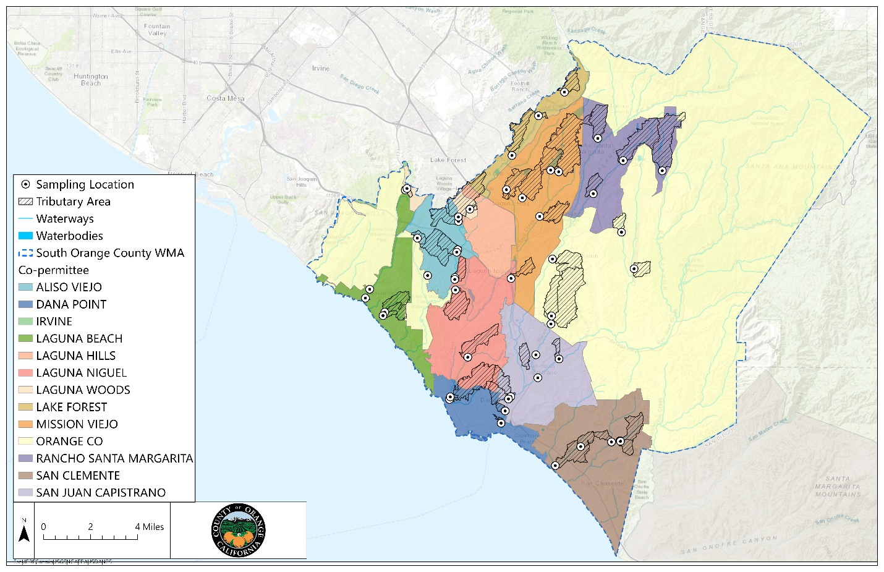

Figure -5. Dry Weather Outfall Sampling Locations.

#### Non-Stormwater Action Levels

Analytical results from water quality non-stormwater discharge sampling are presented in **Attachment 2-3.** The entire CEDEN formatted water quality dataset is available in the South Orange County Regional Clearinghouse[3].

**Figure 2‑6** shows box and whisker plots for the data collected from flowing outfalls during the reporting year for the NALs parameters. The change in grey shading represents the median. Results exceeding the NALs are represented in orange. **Figure 2‑6** shows over 50% of the samples collected exceeded the NALs for fecal coliform, enterococcus, total nitrogen, total phosphorus, and manganese.

The percentage of samples collected with elevated parameters relative to the NALs and median results are summarized in **Table 2‑4**. Concentrations at each outfall relative to NALs are shown in **Attachment 2-4**.

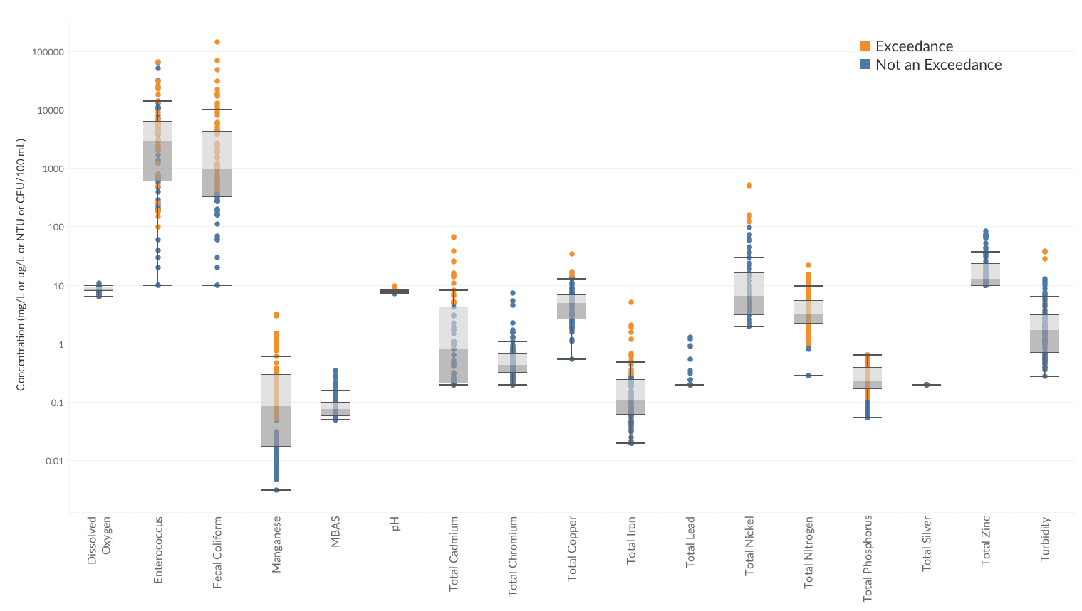

Figure 2‑6. Dry Weather Outfall Chemistry (NALs parameters).

Table ‑. Summary of NALs Exceedances.

|  |  |  |  |
| --- | --- | --- | --- |
| **Parameter** | **NAL** | **Percentage of Samples Exceeding NALsb** | **Median** |
| Dissolved Oxygen | Not less than 5 mg/L for WARM and not less than 6.0 mg/L for COLDa | 0 | 8.6 |
| Turbidity | 20 NTU | 2 | 1.7 |
| pH | Within 6-5 to 8.5 | 4 | 8.0 |
| Fecal Coliform | 400 MPN/100 mL | 72 | 1000 |
| Enterococcic | 61 MPN 100 mL | 93 | 2,950 |
| Total Nitrogen | 1.0 mg/L | 99 | 3.3 |
| Total Phosphorus | 0.1 mg/L | 93 | 0.25 |
| MBAS | 0.5 mg/L | 2 | 0.08 |
| Iron | 0.3 mg/L | 20 | 0.10 |
| Manganese | 0.05 mg/L | 64 | 0.09 |
| Cadmiumd | 5 µg/L | 21 | 0.52 |
| Copperd | 16 – 31 µg/L | 1 | 4.9 |
| Chromium (Total)d | 50 µg/L | 0 | 0.43 |
| Chromium IIId | 50 µg/L | 0 | 0.23 |
| Chromium VId | 16 µg/L | 0 | 0.20 |
| Leadd | 7 – 19 µg/L | 0 | <0.2 |
| Nickeld | 100 µg/L | 9 | 5.8 |
| Silverd | 8 – 44 µg/L | 0 | <0.2 |
| Zinc (Total)d | 168 – 388 µg/L | 0 | 12 |
| Zinc (Dissolved)d | 168 – 388 µg/L | 0 | 10 |

a Applies to San Juan Creek watershed.

b Percentage computed from total number of samples collected.

c NAL not applicable to water bodies that are not designated with the water contact recreation (REC-1) beneficial use. Median includes all data.

d Priority pollutantsevaluated according to maximum contaminant levels or California Toxics Rule.

### Non-Stormwater Discharge Assessments

#### Identify Controllable Sources of Transient and Persistent Flows, and Sources Contributing to NALs Exceedances

Information gathered from Permittees on identifying controllable sources of transient and persistent flow is provided in **Attachment 2-4**. **Figure 2‑7** summarizes what jurisdictions identified as potential flow sources contributing to NAL exceedances as determined from water quality samples. The y-axis represents the total number of responses from all Permittees for each potential source category. It is unknown if the flow sources provided in the plot are associated with NAL exceedances.

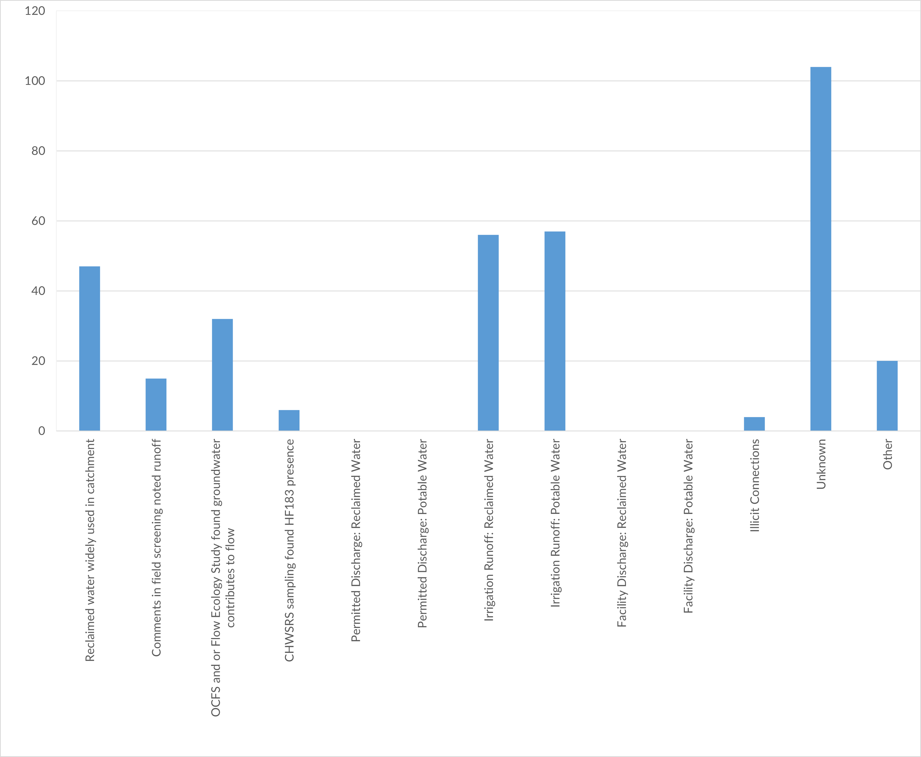

Figure 2‑7. Potential Sources Contributing to NALs Exceedances.

#### Non-stormwater Volumes and Pollutant Loads

Jurisdictional non-stormwater volumes for drains with connectivity to receiving waters, including total volumes and area-normalized volumes for monitoring year 2023-24, are provided in **Table 2‑5**.

Table 2‑5. Jurisdictional Non-Stormwater Volume Connected to Receiving Water per Monitoring Year (October 1 – September 30).

|  |  |  |  |
| --- | --- | --- | --- |
| **Jurisdiction** | **Area (acres)** | **2022-23** | |
| **Acre feet** | **Cubic feet per acre** |
| Aliso Viejo | 4,299 | 237 | 2,398 |
| Dana Point | 4,072 | 208 | 2,225 |
| Laguna Beach | 5,632 | 106 | 817 |
| Laguna Hills | 3,498 | 387 | 4813 |
| Laguna Niguel | 9,464 | 2,689 | 12,376 |
| Laguna Woods | 756 | 94 | 5,435 |
| Lake Forest | 3,303 | 193 | 2,546 |
| Mission Viejo | 11,525 | 1,419 | 5,361 |
| Rancho Santa Margarita | 8,280 | 917 | 4,828 |
| San Clemente | 11,739 | 1,138 | 4,225 |
| San Juan Capistrano | 9,220 | 535 | 2,527 |
| Unincorporated | 94,761 | 1,940 | 892 |
| **South OC WMA Total** | **166,551** | **7,998** |  |
| **South OC WMA Average** |  | **1,374** | **3,726** |
| **South OC WMA Minimum** |  | **94** | **817** |
| **South OC WMA Maximum** |  | **2,689** | **12,376** |

Annual jurisdictional discharge results for each outfall connected to receiving water are provided in **Attachment 2-6** for the 2023-24 Monitoring Year.

Jurisdictional pollutant loading results for priority pollutants are provided for the 2023-24 monitoring years in **Table 2‑6**, **Table 2‑7**, **Table 2‑8**. Full results for all parameters for each jurisdiction are provided in **Attachment 2-7** for the 2023-24 monitoring year.

Table ‑. 2023-24 Non-Metals Non-Stormwater Pollutant Loads.

|  |  |  |  |  |  |
| --- | --- | --- | --- | --- | --- |
| **Jurisdiction** | **Fecal coliforms (trillions CFU)** | ***Enterococcus* (trillions CFU)** | **Total N (pounds)** | **Total Phosphorus as P (pounds)** | **MBAS (pounds)** |
| Aliso Viejo | 23 | 22 | 4,528 | 173 | 41 |
| Dana Point | 11 | 9.8 | 2,133 | 122 | 72 |
| Laguna Beach | 0.36 | 0.37 | 288 | 25 | 25 |
| Laguna Hills | 45 | 3.8 | 3,066 | 68 | 178 |
| Laguna Niguel | 24 | 93 | 22,008 | 1,459 | 484 |
| Laguna Woods | 7.4 | 0.65 | 497 | 11 | 29 |
| Lake Forest | 20 | 5.3 | 3,044 | 154 | 49 |
| Mission Viejo | 297 | 358 | 14,666 | 1,167 | 423 |
| Rancho Santa Margarita | 103 | 109 | 6,713 | 825 | 204 |
| San Clemente | 89 | 190 | 12,343 | 885 | 194 |
| San Juan Capistrano | 10 | 14 | 6,550 | 285 | 84 |
| Unincorporated | 92 | 101 | 30,353 | 1,687 | 437 |

Table ‑. 2023-24 Total Metals Non-Stormwater Pollutant Loads (pounds).

|  |  |  |  |  |  |  |  |  |  |
| --- | --- | --- | --- | --- | --- | --- | --- | --- | --- |
| **Jurisdiction** | **Fe** | **Mn** | **Cd** | **Cu** | **Cr** | **Pb** | **Ni** | **Ag** | **Zn** |
| **Pounds** | | | | | | | | |
| Aliso Viejo | 106 | 67 | 0.80 | 3.2 | 0.81 | 0.15 | 5.6 | 0.06 | 11 |
| Dana Point | 128 | 287 | 2.5 | 5.5 | 0.31 | 0.2 | 27 | 0.06 | 17 |
| Laguna Beach | 19 | 25 | 0.03 | 0.41 | 0.08 | 0.03 | 1.0 | 0.03 | 1.3 |
| Laguna Hills | 10 | 395 | 0.49 | 3.5 | 0.54 | .1 | 4.2 | 0.1 | 5.2 |
| Laguna Niguel | 706 | 2,013 | 20 | 43 | 3 | 1.7 | 166 | 0.73 | 123 |
| Laguna Woods | 1.7 | 64 | 0.08 | 0.57 | 0.09 | 0.02 | 0.69 | 0.02 | 0.85 |
| Lake Forest | 78 | 108 | 0.166 | 3 | 0.33 | 0.1 | 2.0 | 0.05 | 4.9 |
| Mission Viejo | 531 | 1,355 | 36 | 20 | 1.7 | 0.52 | 142 | 0.39 | 64 |
| Rancho Santa Margarita | 670 | 357 | 21 | 12 | 0.82 | 0.27 | 30 | 0.25 | 31 |
| San Clemente | 453 | 2,103 | 35 | 9.1 | 1.9 | 0.47 | 293 | 0.21 | 69 |
| San Juan Capistrano | 172 | 57 | 0.74 | 4.1 | 0.43 | 0.13 | 8 | 0.13 | 21 |
| Unincorporated OC | 854 | 1,266 | 21 | 21 | 3.1 | 0.72 | 175 | 0.53 | 73 |

Table ‑. 2023-24 Dissolved Metals Non-Stormwater Pollutant Loads (pounds).

|  |  |  |  |  |  |  |  |  |  |
| --- | --- | --- | --- | --- | --- | --- | --- | --- | --- |
| **Jurisdiction** | **Fe** | **Mn** | **Cd** | **Cu** | **Cr** | **Pb** | **Ni** | **Ag** | **Zn** |
| **Pounds** | | | | | | | | |
| Aliso Viejo | 71 | 66 | 0.75 | 2.9 | 0.7 | 0.12 | 5.5 | 0.06 | 10 |
| Dana Point | 31 | 280 | 1.0 | 4.2 | 0.26 | 0.08 | 25 | 0.06 | 15 |
| Laguna Beach | 8.2 | 24 | 0.03 | 0.45 | 0.07 | 0.03 | 1.1 | 0.03 | 1.3 |
| Laguna Hills | 11 | 395 | 0.49 | 3.5 | 0.54 | 0.1 | 4.2 | 0.1 | 5.2 |
| Laguna Niguel | 610 | 1,987 | 18 | 40 | 2.9 | 1.4 | 166 | 0.73 | 120 |
| Laguna Woods | 1.7 | 64 | 0.08 | 0.56 | 0.09 | 0.02 | 0.69 | 0.02 | 0.85 |
| Lake Forest | 53 | 105 | 0.17 | 2.8 | 0.3 | 0.08 | 2 | 0.05 | 3.8 |
| Mission Viejo | 249 | 1,320 | 24 | 17 | 1.4 | 0.41 | 142 | 0.39 | 48 |
| Rancho Santa Margarita | 597 | 353 | 7.0 | 12 | 0.77 | 0.27 | 30 | 0.25 | 27 |
| San Clemente | 243 | 2,097 | 34 | 8.2 | 1.5 | 0.34 | 292 | 0.21 | 61 |
| San Juan Capistrano | 101 | 54 | 0.51 | 3.8 | 0.35 | 0.13 | 8.2 | 0.13 | 20 |
| Unincorporated OC | 673 | 1,224 | 21 | 19 | 2.8 | 0.86 | 174 | 0.53 | 70 |

### Wet Weather MS4 Outfall Discharge Monitoring

**Figure 2-8** shows the locations of the outfalls for stormwater MS4 outfall discharge sampling and the drainage area for all wet weather monitoring locations.

Analytical results from water quality stormwater discharge sampling are presented in **Attachment 2-8.**  The entire CEDEN formatted water quality dataset is available in the South Orange County Regional Clearinghouse[4].

**Table 2‑9** shows thecalculated area-weighted runoff coefficients for the tributary of each sampled outfall and estimated annual stormwater volumes. **Table 2‑10, Table 2‑11**, and **Table 2‑12** summarize results for bacteria, pesticides, and polycyclic aromatic hydrocarbons.

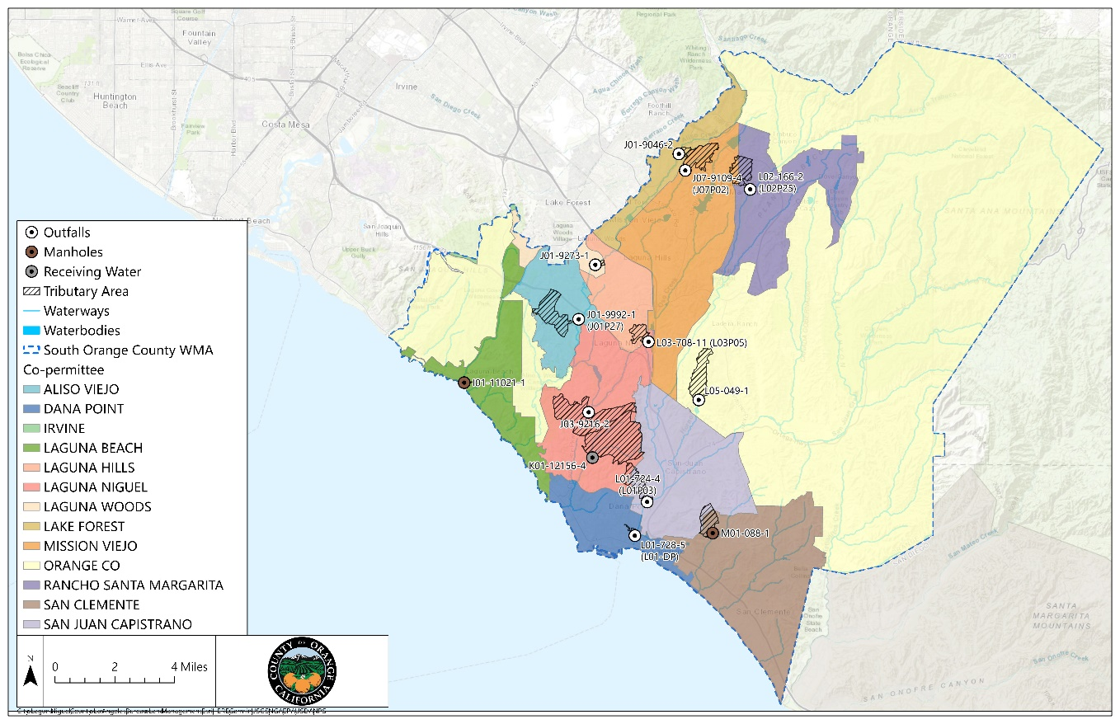

Figure -8. Wet Weather Outfall Monitoring Locations.

Table ‑. Outfall Stormwater Volumes.

| **Station** | **Area (acres)** | **Annual Rainfall (inches)a** | **Runoff Coefficient** | **Annual Stormwater Volume (acre-ft)** |
| --- | --- | --- | --- | --- |
| Horno/u | 478.27 | 20.56 | 0.33 | 267 |
| J01P27 | 553.84 | 20.56 | 0.43 | 409 |
| J01ASVM | 30.7 | 19.47 | 0.48 | 24 |
| J01-Norm | 46.36 | 19.47 | 0.36 | 27 |
| J03P01in | 1,123.29 | 20.56 | 0.37 | 715 |
| J07P02 | 394.93 | 19.47 | 0.4 | 255 |
| L01-DP | 24.72 | 17.71 | 0.42 | 15 |
| L01P03 | 349.72 | 19.47 | 0.35 | 201 |
| L02P25 | 363.95 | 22.96 | 0.38 | 266 |
| L03P05 | 171.71 | 20.56 | 0.36 | 106 |
| SC-Fortuna | 304.04 | 19.47 | 0.26 | 126 |
| SCNK01 | 1,412.69 | 20.56 | 0.32 | 772 |
| Victra u/s P | 15.02 | 16.53 | 0.47 | 9.6 |

**a**Sum of daily rainfall greater than 0.1”

Table 2‑10. Bacterial Concentrations in Storm Samples.

|  |  |  |  |  |  |
| --- | --- | --- | --- | --- | --- |
| **Bacteria (CFU/100mL)** | **Number of samples collected** | **Number of samples below the reporting limit** | **Minimum** | **Maximum** | **Median** |
| *Enterococcus* (CFU/100 ml) | 13 | 0 | >=4000 | 43,000 | 10000 |
| Fecal Coliform (CFU/100 mL) | 13 | 0 | 300 | 31000 | >=5100 |
| Total Coliform (CFU/100 mL) | 13 | 0 | >=21,000 | >=108,000 | 61,000 |
| *E. coli* (CFU/100 mL) | 13 | 0 | 2,500 | 31,000 | 8,200 |

**Table 2‑11. Pesticide Concentrations in Storm Samples.**

|  |  |  |  |  |  |
| --- | --- | --- | --- | --- | --- |
| **Constituent** | **Number of samples collected** | **Number of samples below the reporting limit** | **Minimum** | **Maximum** | **Median** |
| BHC-delta (ng/L) | 13 | 13 | <5 | <5 | <5 |
| Chlordane-alpha | 13 | 12 | <2 | 5.19 | <2 |
| Chlordane-gamma | 13 | 11 | <2 | 4 | <2 |
| Chlorpyrifos (ng/L) | 13 | 13 | <1 | <1 | <1 |
| Diazinon (ng/L) | 13 | 13 | <1 | <1 | <1 |
| Dieldren (ng/L) | 13 | 13 | <2 | <2 | <2 |
| 2,4'-DDE (ng/L) | 13 | 13 | <2 | 2.54 | <2 |
| 4,4'-DDE (ng/L) | 13 | 13 | <2 | <2 | <2 |
| Ethyl Parathion (ng/L) | 13 | 13 | <20 | <20 | <20 |
| Malathion (ng/L) | 13 | 11 | <5 | 40.2 | <5 |
| Toxaphene | 13 | 11 | <25 | 147 | <25 |
| trans-Nonachlor | 13 | 10 | <2 | 4.99 | <2 |

Table 2‑12. Polycyclic Aromatic Hydrocarbon Concentrations in Storm Samples (ng/L).

|  |  |  |  |  |  |
| --- | --- | --- | --- | --- | --- |
| **Constituent** | **Number of samples collected** | **Number of samples below the reporting limit** | **Minimum** | **Maximum** | **Median** |
| Acenaphthylene | 13 | 11 | <5 | 12.4 | <5 |
| Anthracene | 13 | 8 | <5 | 7.82 | <5 |
| Benz[a] anthracene | 13 | 8 | <5 | 7.26 | <5 |
| Benzo[b] fluoranthene | 13 | 9 | <5 | 18.2 | <5 |
| Benzo[k] fluoranthene | 13 | 10 | <5 | 9.76 | <5 |
| Benzo[g,h,i] perylene | 13 | 10 | <5 | 12.1 | <5 |
| Benzo[a] pyrene | 13 | 6 | <5 | 67.1 | <5 |
| Biphenyl | 13 | 11 | <5 | 30.2 | <5 |
| Chrysene | 13 | 10 | <5 | 19.2 | <5 |
| Dibenz[a,h]anthracene | 13 | 8 | <5 | 64.5 | <5 |
| Dibenzothiophene | 13 | 13 | <5 | <5 | <5 |
| Fluoranthene | 13 | 11 | <5 | 32.7 | <5 |
| Fluorene | 13 | 4 | <5 | 70.1 | 6.62 |
| Indeno [1,2,3-cd]pyrene | 13 | 13 | <5 | <5 | <5 |
| Naphthalene | 13 | 12 | <5 | 6.86 | <5 |
| TCMX | 13 | 5 | <5 | 357 | 10.2 |
| Phenanthrene | 13 | 6 | <5 | 34.7 | <5 |
| Pyrene | 13 | 3 | <5 | 138 | 13.1 |

### Stormwater Action Levels (SALs)

**Figure 2‑9** shows box and whisker plots for data collected during the 2023-24 reporting year at monitored outfalls for the SALs parameters. Results exceeding SALs are represented in orange. **Attachment 2-9** shows a summary of results compared to SALs.

**Figure 2‑10** shows percentages of SAL exceedances from the 2017-18 through the 2023-24 monitoring year. The figure shows that over the past five years, most wet weather samples did not exceed SALs.

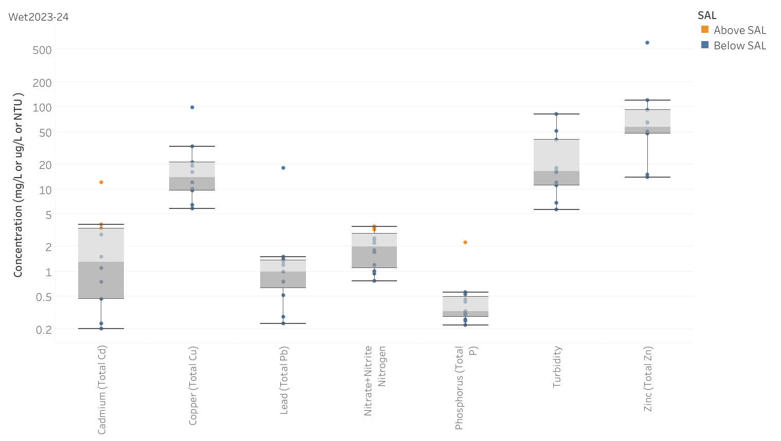

Figure 2‑9. Wet Weather Outfall Chemistry (SALs Parameters).

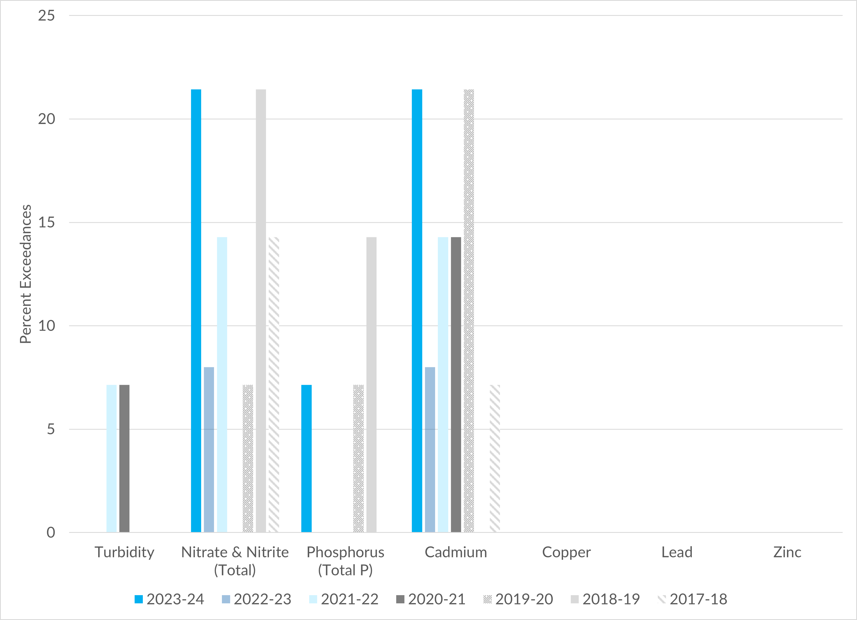

Figure 2‑10. Annual Percentage of SAL Exceedances.

### Stormwater Pollutant Discharges Reduction Assessments

#### Stormwater Discharge Volumes and Pollutant Loads

**Attachment 2-10** shows loading results for each sampled outfall. The annual jurisdictional pollutant loads for each land-use are available as **Attachment 2-11**. The annual outfall tributary loading results for each land-use are available as **Attachment 2-12**.

#### Time-Series Plots and Statistical Analysis

**Figure 2‑11**, **Figure 2‑12**, **Figure 2‑13**, **Figure 2‑14**, and **Figure 2‑15,** show box and whisker plots for concentrations of cadmium, lead, zinc, nitrite and nitrate as N, and total phosphorus from the 2017-18 monitoring year through the 2023-24 monitoring year. The orange dashed line represents the stormwater action level.

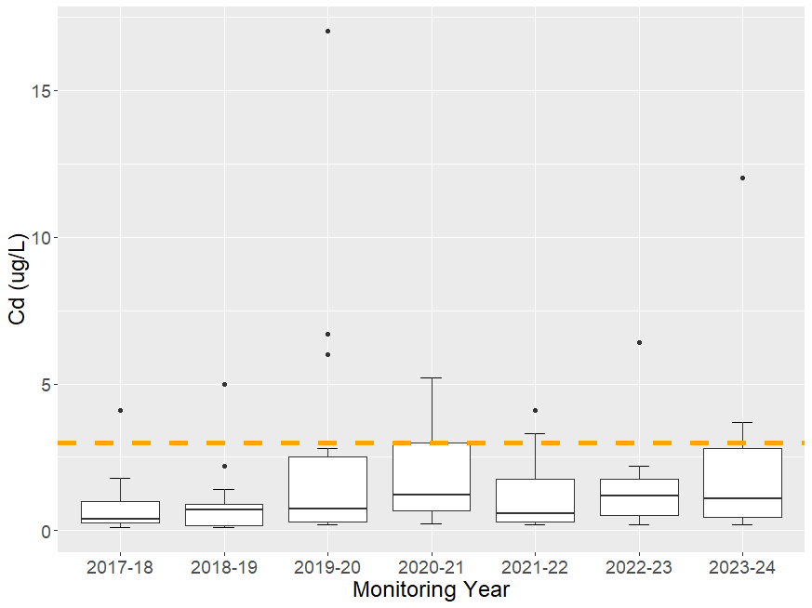

Figure ‑. Cadmium wet weather concentrations.

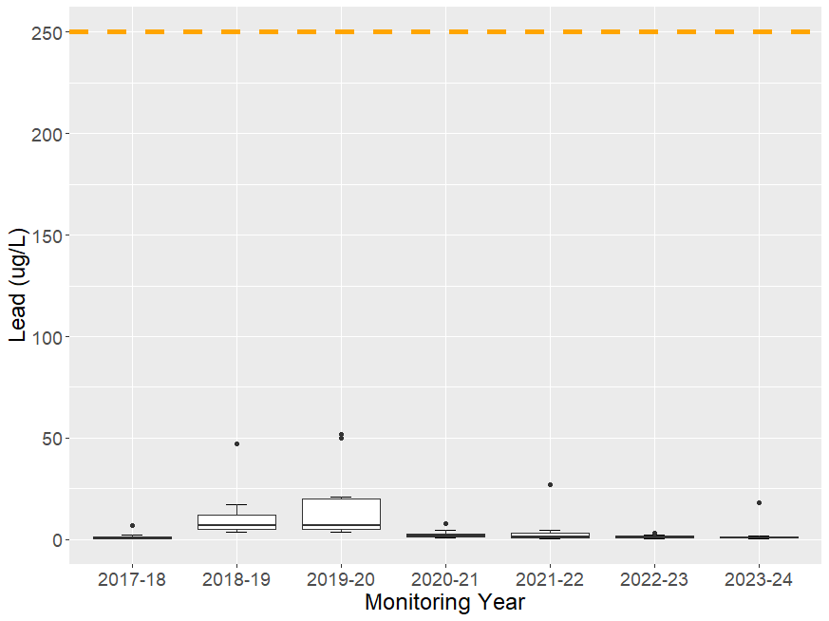

Figure 2‑12. Lead wet weather concentrations.

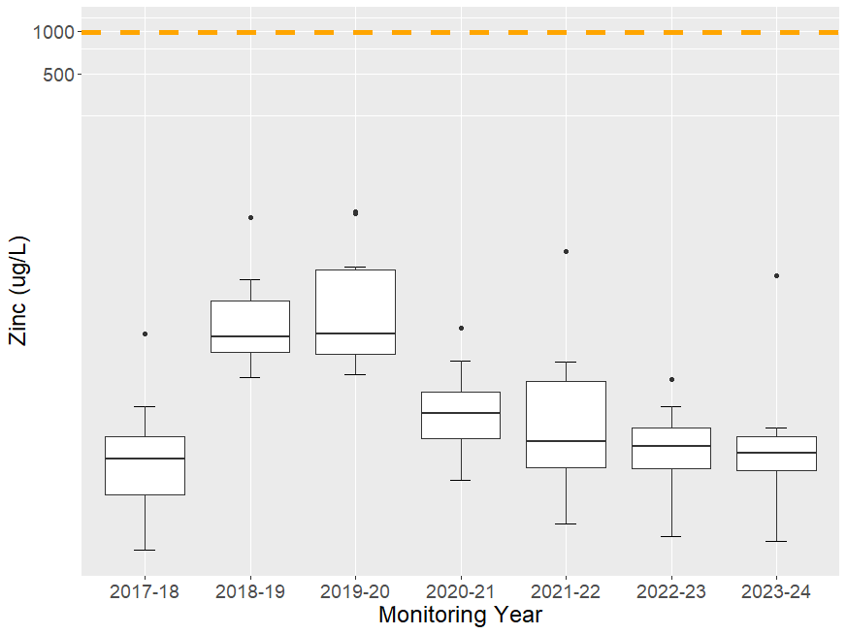

Figure 2‑13. Zinc wet weather concentrations.

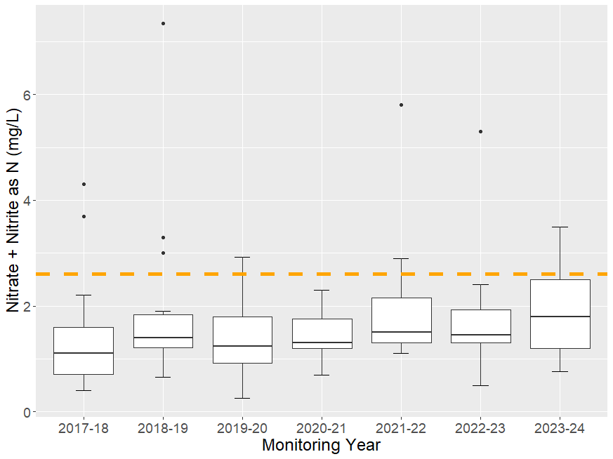

Figure 2‑14. Nitrate + Nitrite as N wet weather concentrations.

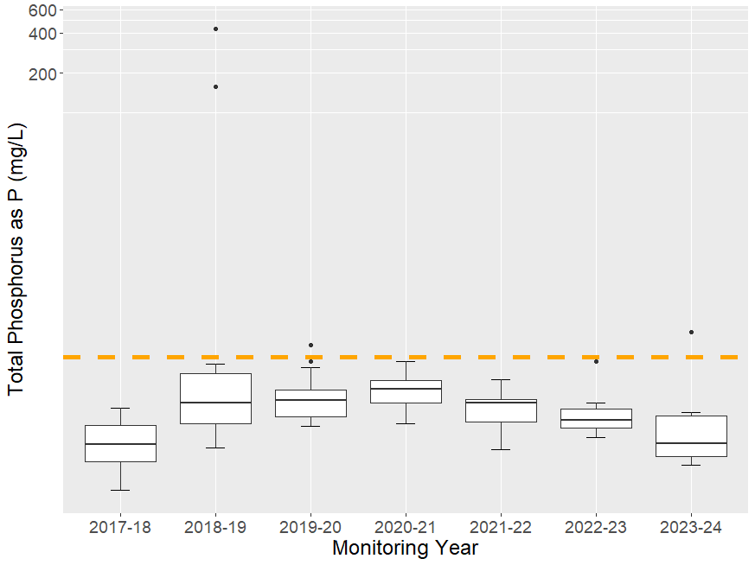

Figure 2‑15. Total Phosphorus as P wet weather concentrations.

1. County of Orange GIS Open Data Portal: https://data-ocpw.opendata.arcgis.com/
2. OCPW Open Data Portal: <https://data-ocpw.opendata.arcgis.com/datasets/780b8317d3e144b4bfaeed3f2accad6e_0>
3. South Orange County Regional Clearing House: <https://ocgov.box.com/v/2022-23WQIPCEDENData>
4. [SDR Water Quality Data - OC Watersheds](https://ocgov.app.box.com/folder/11445955618?s=vmt8zqco9qg65cfx4zhxchamczp9dz7y)